Assignment1 Report
Platform (Colab/Kaggle/Local): Local
Python version: 3.10.12
Operating system: Ubuntu 24.04
CPU: AMD Ryzen 7 8845HS
GPU requirement: NVIDIA GeForce RTX 4050 Laptop GPU
- Which embedding model do you use? What are the pre-processing steps? What are the hyperparameter settings? (5%)
Answer:
Embedding model: Word2Vec; Pre-processing steps: I use gensim.utils.simple_preprocess(doc, deacc=True, min_len=1, max_len=30) to convert a document into a list of tokens that are lowercased and de-accented. In addition, I remove all stopwords to complete the pre-processing; Hyperparameters: vector_size=100, window=5, min_count=5, sg=1 (Skip-gram), negative=10, sample=1e-3, epochs=5, workers=15. These are common settings.
- What will the performance be like if you sample 5%, 10% and 20% of wiki text in TODO4? (10%, 3% for each)
Answer:
In the Semantic category, only the “Family” sub-category showed measurable (non-zero) accuracy. In the Syntactic category, an increase in accuracy is not strictly guaranteed by a higher sampling ratio for every sub-category (e.g., gram1-adjective-to-adverb and gram4-superlative). I suppose that performance depends on the specific data sampled. However, accuracy generally improved across most items as the sampling ratio increased.
 |  | Sample 5% | Sample 10% | Sample 20%
Category | Semantic | 3.53% | 3.56% | 3.83%
 | Syntactic | 25.45% | 25.36% | 26.97%
Sub-Category | capital-common-countries | 0.00% | 0.00% | 0.00%
 | capital-world | 0.00% | 0.00% | 0.00%
 | currency | 0.00% | 0.00% | 0.00%
 | city-in-state | 0.00% | 0.00% | 0.00%
 | family | 61.86% | 62.45% | 67.19%
 | gram1-adjective-to-adverb | 17.84% | 15.63% | 16.73%
 | gram2-opposite | 9.36% | 10.47% | 16.01%
 | gram3-comparative | 42.72% | 41.59% | 42.94%
 | gram4-superlative | 15.24% | 14.88% | 18.72%
 | gram5-present-participle | 22.63% | 22.35% | 23.20%
 | gram6-nationality-adjective | 0.00% | 0.00% | 0.00%
 | gram7-past-tense | 41.15% | 40.83% | 42.76%
 | gram8-plural | 47.75% | 49.17% | 49.32%
 | gram9-plural-verbs | 23.79% | 25.06% | 26.67%
Across the three experimental conditions (5%, 10%, and 20% data samples), the t-SNE visualization of the words demonstrates clear partitioning of the word groups. For the Family sub-category, increasing the sample size did not lead to a noticeable difference in the tightness or clarity of the cluster compared with the smaller sample.
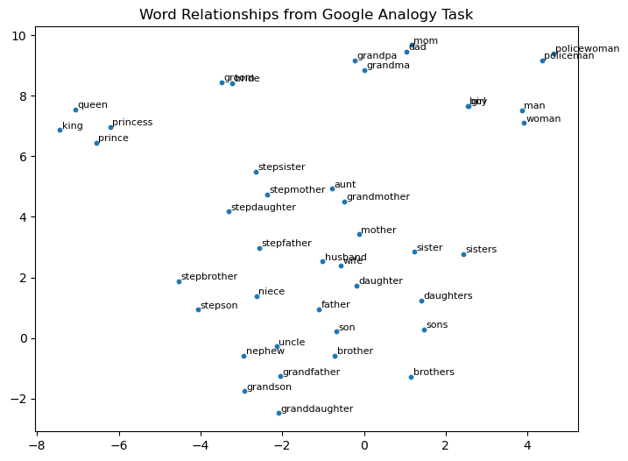
Figure 1. Sampling Ratio = 5%
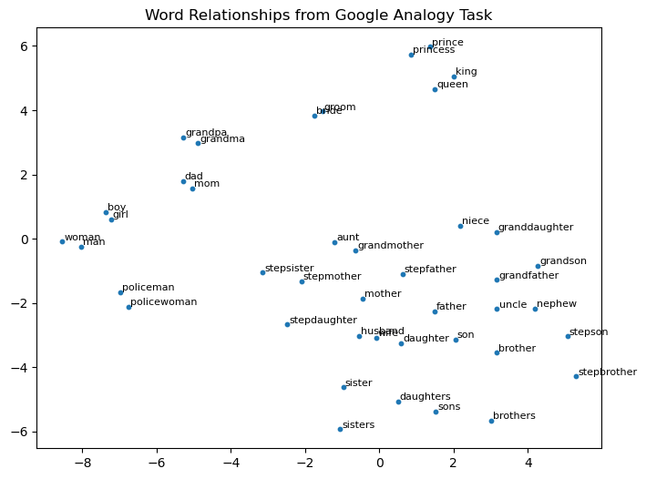
Figure 2. Sampling Ratio = 5%
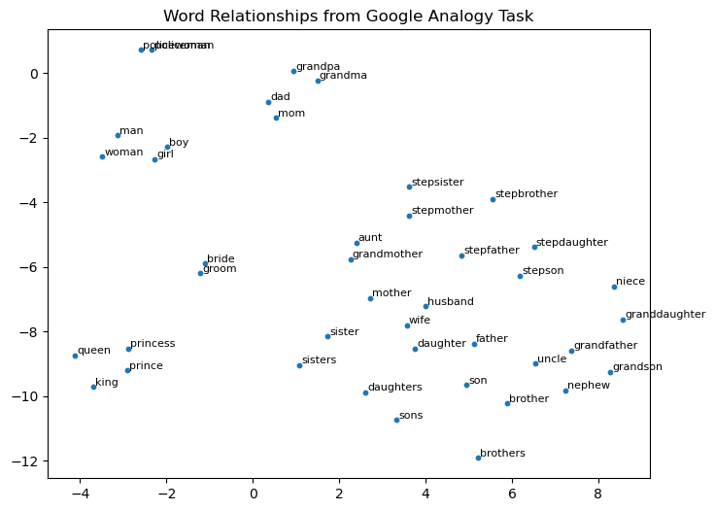
Figure 3. Sampling Ratio = 5%
- What is the performance for different categories or sub-categories when trained on different corpora? (15%)
3.1 Present your results. (5%)
Answer:
When I add finance text to a 5% sample of the wikitext, the categories and most of sub-categories of the model’s accuracy decreases, and those zero-accuracy subcategories are still at zero. I suppose that the finance text I used was too little.
 |  | Sample 5% | Sample 5% + finance
Category | Semantic | 3.53% | 3.35% ⭣
 | Syntactic | 25.45% | 23.23% ⭣
Sub-Category | capital-common-countries | 0.00% | 0.00%
 | capital-world | 0.00% | 0.00%
 | currency | 0.00% | 0.00%
 | city-in-state | 0.00% | 0.00%
 | family | 61.86% | 58.70% ⭣
 | gram1-adjective-to-adverb | 17.84% | 11.59% ⭣
 | gram2-opposite | 9.36% | 11.08% ⭣
 | gram3-comparative | 42.72% | 36.41% ⭣
 | gram4-superlative | 15.24% | 12.03% ⭣
 | gram5-present-participle | 22.63% | 23.30% ⭡
 | gram6-nationality-adjective | 0.00% | 0.00%
 | gram7-past-tense | 41.15% | 35.51% ⭣
 | gram8-plural | 47.75% | 49.25% ⭡
 | gram9-plural-verbs | 23.79% | 22.87% ⭣
I further analyzed the subcategory “gram2-opposite” in the two models because of its increasing accuracy. Below is the word relationship of the subcategory “gram2-opposite.” We can see that the group partition of the model with finance text is clearer.
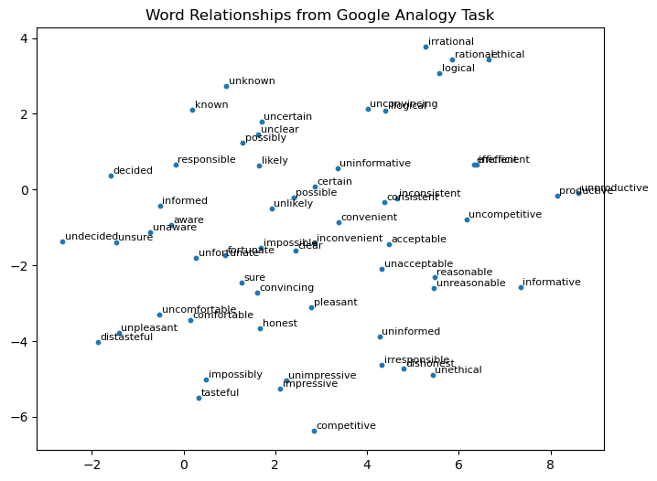
Figure 4. 5% wikitext sample
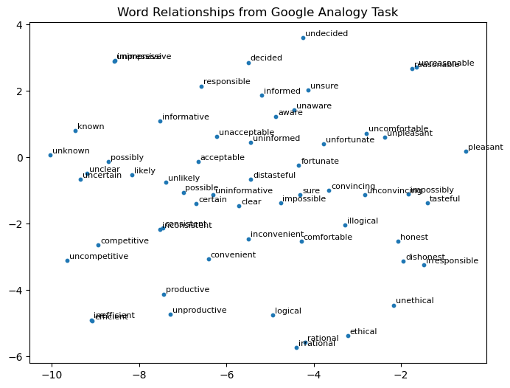
Figure 5. 5% wikitext sample + finance text
3.2 Introduce the corpus you selected and explain the differences between the Wikipedia corpus and your corpus. (including data size, topic difference, structural difference … ) (5%)
Answer:
Considering the previous results, which showed that the accuracy of the sub-category “currency” was 0%, I download ankurzing/sentiment-analysis-for-financial-news and build a currency corpus. Then, I combined the 5% Wikipedia corpus (provided by the NLP lesson) and the currency corpus to train the model. The differences between the Wikipedia corpus and my corpus are as follows.
 | Wikipedia corpus | My corpus
Dataset | Wiki texts | Wiki texts + financial news
Data size | 994 MB | 994 MB + 730 KB
Topic | Multiple fields | Multiple fields + Single domain focus on currency
Structure | Article paragraphs, diverse and longer sentence | News headlines, short sentences

3.3 Explain why the accuracy increases or decreases. (5%)
Answer:
I trained my model using my own corpus and aimed to strengthen the Wikipedia corpus with a specific domain field. However, this addition negatively influenced other fields, leading to a decrease in their accuracy. The primary reason is that the model could not adequately focus on the target field, and the dataset for this domain was too small to capture meaningful relationships.
- Select a few words and use their embeddings to retrieve the five most similar words and present the results. What do you observe? (10%)
Answer:
By selecting one representative word from four t-SNE clusters and retrieving its five most similar words, I observe that each top-five list exhibits high semantic relevance to the query word.
 | daughter | grandma | king | man
#1 | wife | grandpa | itsarasunthon | woman
#2 | son | pettitoes | silamegha | boy
#3 | mother | meemaw | throne | girl
#4 | married | peepaw | ekathotsarot | person
#5 | eldest | bumbie | prince | disenchants
Besides, by selecting four words (king, queen, prince, princess) from same cluster and retrieving their top five most similar words, I observe that their top five most similar neighbors are almost proper nouns (e.g., names of kings). I suppose that the model was trained on detailed articles. Thus, the resulting word vectors are heavily influenced by such non-general terms, making the learned relationships highly corpus-specific rather than broadly generalizable.
 | king | queen | prince | princess
#1 | itsarasunthon | princess | princess | prince
#2 | silamegha | saovabha | savangwongse | princesses
#3 | throne | kumariratana | kashemsanta | bajrakitiyabha
#4 | ekathotsarot | phongsri | dipangkorn | sirivannavari
#5 | prince | amarindra | bhanurangsi | nariratana

- Anything that can strengthen your report. (5%)
Answer:
To address the problem where the resulting word vectors are heavily influenced by non-general terms, I adjusted the hyperparameter window size from 5 to 20 in an attempt to improve the situation and to ensure that the five most similar words are not proper nouns.
When the window size is changed from 5 to 20, the training time becomes twice as long as the original. Nevertheless, the top 5 most similar words for the four words (king, queen, prince, princess) are shown as follows and return to normal. Note that if their top results change, I use “➔” to represent their transformation.
 | king | queen | prince | princess
#1 | itsarasunthon ➔ prince | princess | princess | prince
#2 | silamegha ➔ queen | saovabha ➔ king | savangwongse ➔ king | princesses ➔ queen
#3 | throne | kumariratana ➔ prince | kashemsanta ➔ queen | bajrakitiyabha ➔ princesses
#4 | ekathotsarot ➔ reign | phongsri ➔ elizabeth | dipangkorn ➔ throne | sirivannavari ➔ bride
#5 | prince ➔ son | amarindra ➔ lady | bhanurangsi ➔ princes | nariratana ➔ mistress

References:
Word2Vec:
ChatGPT
https://www.kaggle.com/code/pierremegret/gensim-word2vec-tutorial?utm_source=chatgpt.com
https://radimrehurek.com/gensim/auto_examples/tutorials/run_word2vec.html?utm_source=chatgpt.com
https://machinelearningmastery.com/develop-word-embeddings-python-gensim/?utm_source=chatgpt.com
https://sfhsu29.medium.com/nlp-%E5%B0%88%E6%AC%84-1-2-%E5%A6%82%E4%BD%95%E8%A8%93%E7%B7%B4%E8%87%AA%E5%B7%B1%E7%9A%84-word2vec-5a0754c5cb09
t-SNE:
ChatGPT
Introduction to t-SNE: Nonlinear Dimensionality Reduction and Data Visualization | DataCamp
https://scikit-learn.org/stable/modules/generated/sklearn.manifold.TSNE.html
資料降維與視覺化：t-SNE 理論與應用 | Mr. Opengate
Report grammar check:
ChatGPT

